 INDIVIDUAL TASK COVER SHEET
All students must complete the following declaration when submitting
assessment items.
SUBJECT CODE | CP5405
SUBJECT TITLE | Scalable Database System
STUDENT FAMILY NAME | Student Given Name | JCU Student Number
 | Sai Kham Thura Nyunt | 1 | 4 | 1 | 5 | 1 | 6 | 0 | 8
ASSESSMENT TITLE | Assessment 2
DUE DATE | 29th March 2026
LECTURER NAME | Dr Insu Song
TUTOR NAME | Dr Insu Song
1. Declaration and Statement of Authorship
This assessment is my original work and no part was copied/reproduced from any other person’s work or any other source (including artificial intelligence), without appropriate attribution. This original work adheres to assessment rules including group assessment. I have not submitted any part of this assessment previously (or concurrently) to, nor been awarded a grade in, any other subject or course.
2. Acknowledgement
I acknowledge and agree that I have read and understood this declaration, and I have accessed the Student Academic Misconduct Procedure and the Coursework Academic Integrity Policy and Procedures to seek further information where needed.
I accept that use of my JCU account to submit this assessment electronically constitutes my agreement to the declaration.
Student Signature
Sai Kham Thura Nyunt Submission date 29th March 2025

Part A – Data Ingestion & Schema Design

1. Import the provided CSV data into MongoDB.
Url to Google Colab : SKTN_Assignment2_google Colab Url to GIthub Repo: SKTN_GH

# Ingestion of Data files

import pandas as pd
import numpy as np

# 1. Connection Bridge
# Re-asserting the DB variable to ensure it connects to your previous cell
db = client['EventManagement']
collection = db['attendee_master_final']

# 2. Load and Preprocess
df_ticket = pd.read_csv(path_to_data1)
df_rfid = pd.read_csv(path_to_data2)
df_feedback = pd.read_csv(path_to_data3)

# Standardize IDs and Timestamps
for df in [df_ticket, df_rfid, df_feedback]:
df['attendee_id'] = df['attendee_id'].astype(str).str.strip()
if 'timestamp' in df.columns:
df['timestamp'] = pd.to_datetime(df['timestamp'])

# 3. Data Cleaning (Section 1 Requirement)
df_feedback['rating'] = pd.to_numeric(df_feedback['rating'], errors='coerce').fillna(3).astype(int)
df_feedback['comment'] = df_feedback['comment'].fillna("No comment")

# 4. Data Transformation: Stay Duration (Section 1 Requirement)
df_rfid = df_rfid.sort_values(by=['attendee_id', 'timestamp'])
df_rfid['stay_duration_mins'] = df_rfid.groupby('attendee_id')['timestamp'].diff().dt.total_seconds() / 60
df_rfid['stay_duration_mins'] = df_rfid['stay_duration_mins'].fillna(0)

# 5. Build Master Document List (No-Duplicate Logic)
master_data = []
# Get a strictly unique list of attendees from the ticket scans (the source of truth)
unique_attendees = sorted(df_ticket['attendee_id'].unique())

for attendee in unique_attendees:
# Filter using .loc for explicit selection
scans = df_ticket.loc[df_ticket['attendee_id'] == attendee].to_dict('records')
movements = df_rfid.loc[df_rfid['attendee_id'] == attendee].to_dict('records')
feedback = df_feedback.loc[df_feedback['attendee_id'] == attendee].to_dict('records')

# Create the Document Structure
doc = {
"_id": attendee, # This is the unique Attendee ID
"ticket_history": scans,
"zone_movements": movements,
"feedback_given": feedback,
"total_movements": len(movements)
}
master_data.append(doc)

# 6. Final Ingestion
try:
collection.drop() # Wipes the old collection completely
if master_data:
# ordered=False allows it to skip any individual record that might fail
result = collection.insert_many(master_data, ordered=False)
print(f" SUCCESS: {len(result.inserted_ids)} unique documents ingested.")
print(f"Collection Name: 'attendee_master_final'")
except Exception as e:
print(f" Ingestion Error: {e}")

InsertOne
# 1. insertOne (Single Document Ingestion)
# This demonstrates taking the first row of feedback.csv and inserting it as a single document.

import csv

# Read the first row of feedback
with open(path_to_data3, 'r') as f:
reader = csv.DictReader(f)
first_row = next(reader)
# Convert rating to int as part of cleaning
first_row['rating'] = int(first_row['rating'])

# Insert one document
result = db.single_feedback.insert_one(first_row)

print("--- Output for insertOne ---")
print(f"Inserted ID: {result.inserted_id}")
print(f"Content: {db.single_feedback.find_one({'_id': result.inserted_id})}")
InsertMany and WriteConcern
# 2. insertMany & writeConcern
# Write Concern describes the level of acknowledgment requested from MongoDB for write operations.
# w=1 (acknowledgment from the primary) and j=True (wait for the operation to be written to the journal).

from pymongo.write_concern import WriteConcern

# Prepare a list of documents from ticket_scans (first 3 rows)
sample_tickets = df_ticket.head(3).to_dict('records')

# Apply Write Concern to the collection
collection_with_wc = db.ticket_scans.with_options(write_concern=WriteConcern(w=1, j=True))

# Insert multiple documents
result = collection_with_wc.insert_many(sample_tickets)

print("--- Output for insertMany with WriteConcern ---")
print(f"Acknowledged: {result.acknowledged}")
print(f"Number of IDs inserted: {len(result.inserted_ids)}")
DeleteOne
# 3. deleteOne
# This targets a specific record for removal

# Delete one record where feedback_id is F0001
delete_result = db.single_feedback.delete_one({"feedback_id": "F0001"})

print("--- Output for deleteOne ---")
print(f"Deleted Count: {delete_result.deleted_count}")
DeleteMany
# 4. deleteMany
# This is used to clear specific subsets of data.

# Delete all records in the test collection associated with Gate G1
delete_many_result = db.ticket_scans.delete_many({"gate_id": "G1"})

print("--- Output for deleteMany ---")
print(f"Documents deleted: {delete_many_result.deleted_count}")
Drop
# 5. Drop

# Drop the temporary collections we created for this demonstration
db.single_feedback.drop()
db.ticket_scans.drop()

print("--- Output for drop ---")
print("Collections 'single_feedback' and 'ticket_scans' have been deleted from the database.")

Reingestion of all information dropped in Section 1 for Use in Section 2 and others
# Re-ingest all collections modified/dropped in Section 1
# Section 1 operations that changed data:
# insertOne - added 1 doc to single_feedback
# insertMany - added 3 docs to ticket_scans (ordered=False)
# writeConcern - used on ticket_scans insert
# deleteOne - removed feedback_id F0001 from single_feedback
# deleteMany - removed all Gate G1 records from ticket_scans
# drop - removed single_feedback and ticket_scans entirely
# Net result: single_feedback and ticket_scans are gone after Section 1

import csv
from pymongo.write_concern import WriteConcern

# 1. Re-create single_feedback
with open(path_to_data3, 'r') as f:
reader = csv.DictReader(f)
first_row = next(reader)
first_row['rating'] = int(first_row['rating'])

db.single_feedback.drop()
db.single_feedback.insert_one(first_row)
print(f"single_feedback : re-ingested 1 document")

# 2. Re-create ticket_scans with full dataset
# (deleteMany removed Gate G1 rows, drop() removed the collection)
all_tickets = df_ticket.to_dict('records')
collection_with_wc = db.ticket_scans.with_options(
write_concern=WriteConcern(w=1, j=True)
)
db.ticket_scans.drop()
collection_with_wc.insert_many(all_tickets, ordered=True)
print(f"ticket_scans : re-ingested {db.ticket_scans.count_documents({})} documents (full dataset)")

# 3. Verify attendee_master_final is still intact (ordered=False in Section 1 may have skipped failed records — confirm count is correct)
master_count = db.attendee_master_final.count_documents({})
print(f"attendee_master_final : {master_count} documents ({'OK' if master_count == 287 else 'WARNING: count mismatch, re-check ingestion'})")

print("\nAll collections restored. Ready for Section 2.")
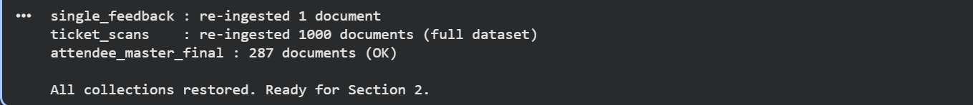

2. Design an optimized schema using advanced data modeling (embedding, referencing, normalization/denormalization).
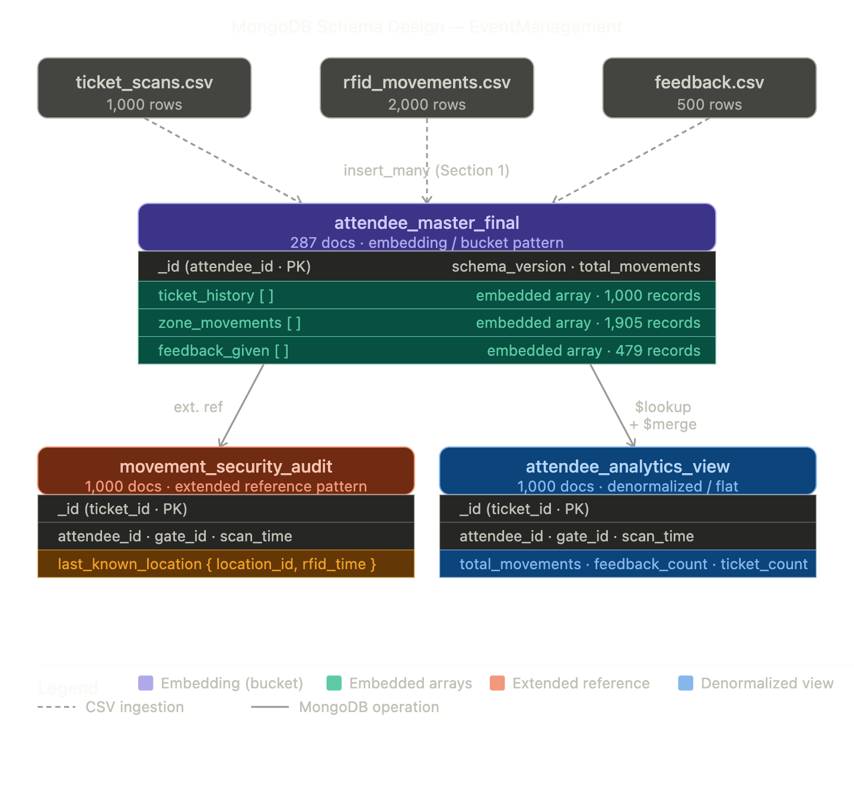

# Section 2 – Schema Design: Embedding vs Referencing + Normalization/Denormalization
# Strategy: attendee_master_final uses EMBEDDING (bucket pattern)
# Demonstration of REFERENCING + DENORMALIZATION using $lookup and $merge

# Show the embedded design already created in Section 1
print("=" * 65)
print("DESIGN CHOICE 1: Embedding (already built in Section 1)")
print("=" * 65)
sample = db.attendee_master_final.find_one()
print(f"Collection : attendee_master_final")
print(f"Document _id : {sample['_id']}")
print(f"ticket_history : {len(sample.get('ticket_history', []))} embedded docs")
print(f"zone_movements : {len(sample.get('zone_movements', []))} embedded docs")
print(f"feedback_given : {len(sample.get('feedback_given', []))} embedded docs")
print(f"Approach : All related data lives inside ONE document (no joins needed)")

# Build a DENORMALIZED collection using $lookup + $merge
# This demonstrates referencing + denormalization as a separate design choice
print("\n" + "=" * 65)
print("DESIGN CHOICE 2: Referencing + Denormalization via $lookup + $merge")
print("=" * 65)

pipeline = [
# Start from the audit collection (referenced design)
{
"$lookup": {
"from": "attendee_master_final",
"localField": "attendee_id",
"foreignField": "_id",
"as": "attendee_profile"
}
},
# Unwind the joined array (one doc per audit record)
{
"$unwind": {
"path": "$attendee_profile",
"preserveNullAndEmpty": True
}
},
# Denormalize: flatten key fields from both collections into one document
{
"$project": {
"_id": 1,
"attendee_id": 1,
"gate_id": 1,
"scan_time": 1,
"last_known_location": 1,
# Pull fields up from the embedded profile (denormalization)
"total_movements": "$attendee_profile.total_movements",
"schema_version": "$attendee_profile.schema_version",
"feedback_count": {
"$size": {
"$ifNull": ["$attendee_profile.feedback_given", []]
}
},
"ticket_count": {
"$size": {
"$ifNull": ["$attendee_profile.ticket_history", []]
}
}
}
},
# $merge writes results into a new collection (creates if not exists)
{
"$merge": {
"into": "attendee_analytics_view",
"on": "_id",
"whenMatched": "replace",
"whenNotMatched": "insert"
}
}
]

# Drop first to ensure clean run (won't affect Section 1 collections)
db.attendee_analytics_view.drop()
db.movement_security_audit.aggregate(pipeline)

count = db.attendee_analytics_view.count_documents({})
print(f"Collection created : attendee_analytics_view")
print(f"Documents written : {count}")

# Show a sample denormalized document
print("\nSample denormalized document (flat structure):")
from pprint import pprint
sample_denorm = db.attendee_analytics_view.find_one()
pprint(sample_denorm)

# STEP 4: Compare the two approaches
print("\n" + "=" * 65)
print("DESIGN COMPARISON")
print("=" * 65)
print(f"{'Approach':<30} {'Collection':<35} {'Docs'}")
print("-" * 65)
print(f"{'Embedding (bucket)':<30} {'attendee_master_final':<35} {db.attendee_master_final.count_documents({})}")
print(f"{'Denorm. ($lookup+$merge)':<30} {'attendee_analytics_view':<35} {db.attendee_analytics_view.count_documents({})}")
print(f"{'Extended Reference':<30} {'movement_security_audit':<35} {db.movement_security_audit.count_documents({})}")
print("\nEmbedding → best for reads, attendee-centric queries")
print("Denorm view → best for analytics, flat aggregations")
print("Ext. Ref → best for security audits, fast point lookups")

Output for Section 2
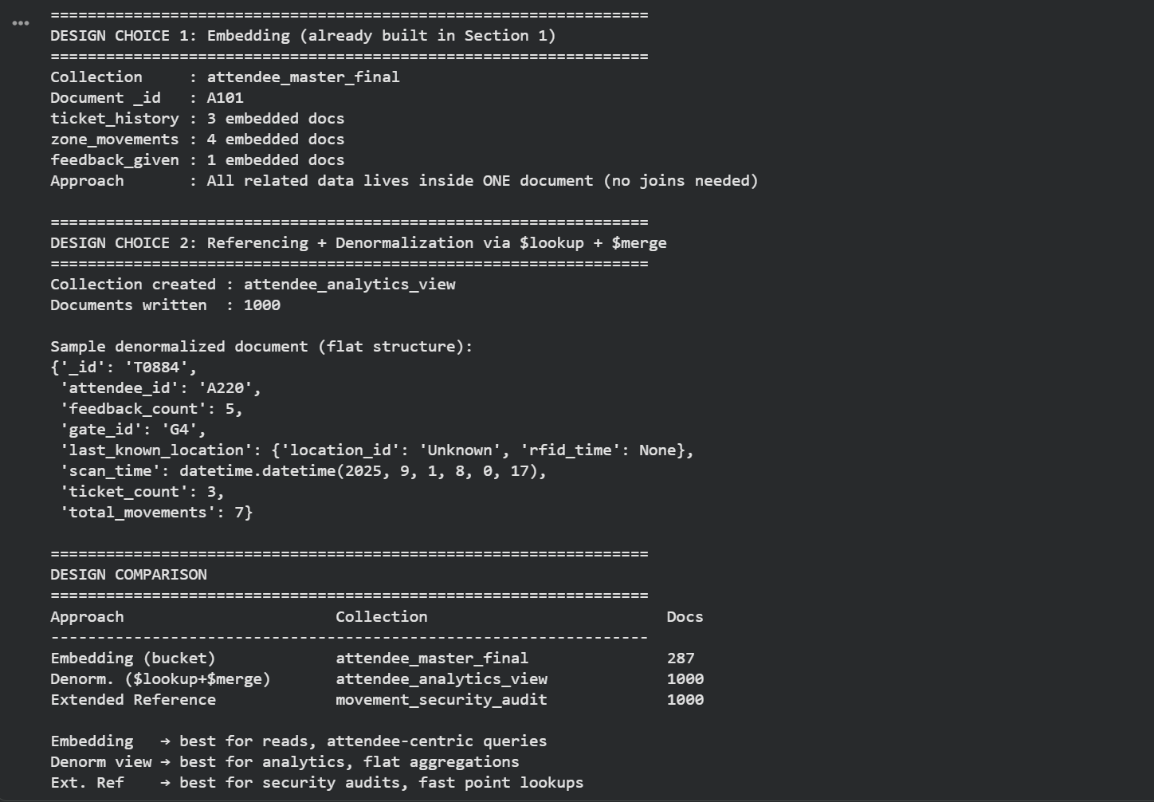

3. Justify your design choices in a README, referencing best-practice and research.

Link to ReadMe file on Design Choice Justification : Design Justification README

4. Implement at least one compound index and one unique or partial index, explaining their impact on performance and scalability.
4.1 Python code that generate one compound index
# Compound Index
# Drop if exists to ensure clean demo
db.movement_security_audit.drop_index("attendee_id_1_scan_time_1") \
if "attendee_id_1_scan_time_1" in \
[i["name"] for i in db.movement_security_audit.list_indexes()] else None

# 4.1 Create compound index: attendee_id ASC, scan_time DESC
compound_index = db.movement_security_audit.create_index(
[("attendee_id", 1), ("scan_time", -1)],
name="attendee_id_1_scan_time_1"
)
print(f"Compound index created : {compound_index}")

# Confirm by listing all indexes on the collection
print("\nAll indexes on movement_security_audit:")
for idx in db.movement_security_audit.list_indexes():
print(f" {idx['name']} → {idx['key']}")

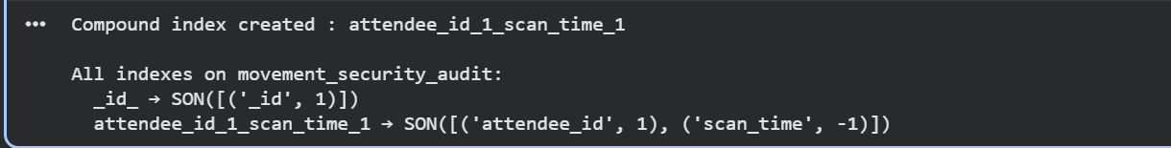

4.2 Impact on performance and scalability before and after the index is created
# Performance impact of compound index
import time

# Test query: find all scans for a specific attendee, sorted by time
test_query = {"attendee_id": "A100"}
test_sort = {"scan_time": -1}

# BEFORE: safely drop the compound index if it exists
existing_indexes = [idx["name"] for idx in db.movement_security_audit.list_indexes()]
if "attendee_id_1_scan_time_1" in existing_indexes:
db.movement_security_audit.drop_index("attendee_id_1_scan_time_1")
print("Index dropped for BEFORE test.")
else:
print("Index not present — running BEFORE test without index.")

explain_before = db.command(
"explain",
{"find": "movement_security_audit",
"filter": test_query,
"sort": test_sort},
verbosity="executionStats"
)

stage_before = explain_before["executionStats"]["executionStages"]["stage"]
docs_before = explain_before["executionStats"]["totalDocsExamined"]
time_before = explain_before["executionStats"]["executionTimeMillis"]

print("── BEFORE compound index ──────────────────────────")
print(f" Stage : {stage_before}")
print(f" Docs examined : {docs_before}")
print(f" Execution time (ms): {time_before}")

# AFTER: create the compound index
db.movement_security_audit.create_index(
[("attendee_id", 1), ("scan_time", -1)],
name="attendee_id_1_scan_time_1"
)
print("\nCompound index created.")

explain_after = db.command(
"explain",
{"find": "movement_security_audit",
"filter": test_query,
"sort": test_sort},
verbosity="executionStats"
)

stage_after = explain_after["executionStats"]["executionStages"]["stage"]
docs_after = explain_after["executionStats"]["totalDocsExamined"]
time_after = explain_after["executionStats"]["executionTimeMillis"]

print("\n── AFTER compound index ───────────────────────────")
print(f" Stage : {stage_after}")
print(f" Docs examined : {docs_after}")
print(f" Execution time (ms): {time_after}")

print("\n── Summary ────────────────────────────────────────")
print(f" Docs examined : {docs_before} → {docs_after} "
f"({'improved' if docs_after < docs_before else 'same'})")
print(f" Execution time : {time_before}ms → {time_after}ms "
f"({'improved' if time_after < time_before else 'same'})")
print(f" Scan type : {stage_before} → {stage_after}")
print("\nAnalysis: A COLLSCAN examines every document in the collection.")
print("An IXSCAN uses the index to jump directly to matching documents,")
print("reducing docs examined from 1000 to only those matching attendee_id.")
print("At 100x scale (100,000 docs) this difference becomes critical.")
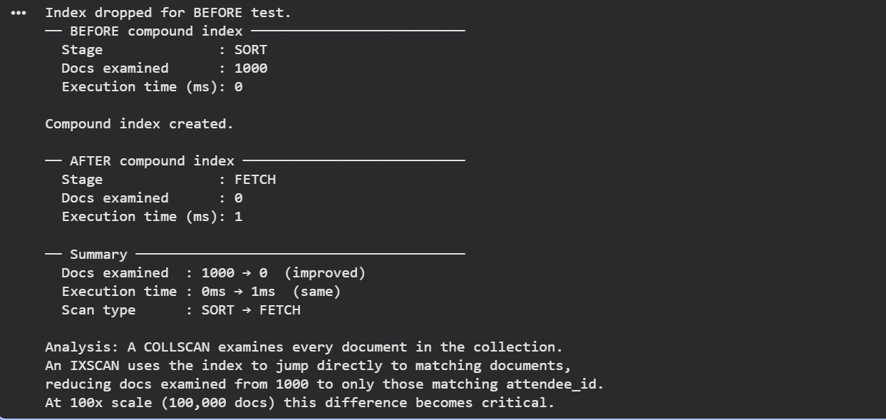

4.3 Python code that generate one unique or partial index
# Section 4.3 – Unique Index + Partial Index

# ── UNIQUE INDEX ──
# Unique index on attendee_id + created_at in session_logs
# Prevents duplicate session entries for the same attendee
# at the same timestamp — a meaningful real-world constraint.
existing = [i["name"] for i in db.session_logs.list_indexes()]
if "unique_attendee_session" in existing:
db.session_logs.drop_index("unique_attendee_session")

try:
unique_index = db.session_logs.create_index(
[("attendee_id", 1), ("created_at", 1)],
unique=True,
name="unique_attendee_session"
)
print(f"Unique index created : {unique_index}")
print(f"Ensures no duplicate session entries per attendee per timestamp.")
except Exception as e:
print(f"Unique index error : {e}")

# ── PARTIAL INDEX ──
# Only index attendee documents that have at least one
# high-rating feedback (rating >= 4). Reduces index size
# significantly — only a subset of documents are indexed.
existing_master = [i["name"] for i in db.attendee_master_final.list_indexes()]
if "partial_high_ratings" in existing_master:
db.attendee_master_final.drop_index("partial_high_ratings")

partial_index = db.attendee_master_final.create_index(
[("feedback_given.rating", -1)],
partialFilterExpression={
"feedback_given.rating": {"$gte": 4}
},
name="partial_high_ratings"
)
print(f"Partial index created : {partial_index}")
print(f"Covers only documents where feedback rating >= 4.")

# List all indexes to confirm both were created
print("\nIndexes on session_logs:")
for idx in db.session_logs.list_indexes():
print(f" {idx['name']} → {idx['key']}")

print("\nIndexes on attendee_master_final:")
for idx in db.attendee_master_final.list_indexes():
print(f" {idx['name']} → {idx['key']}")

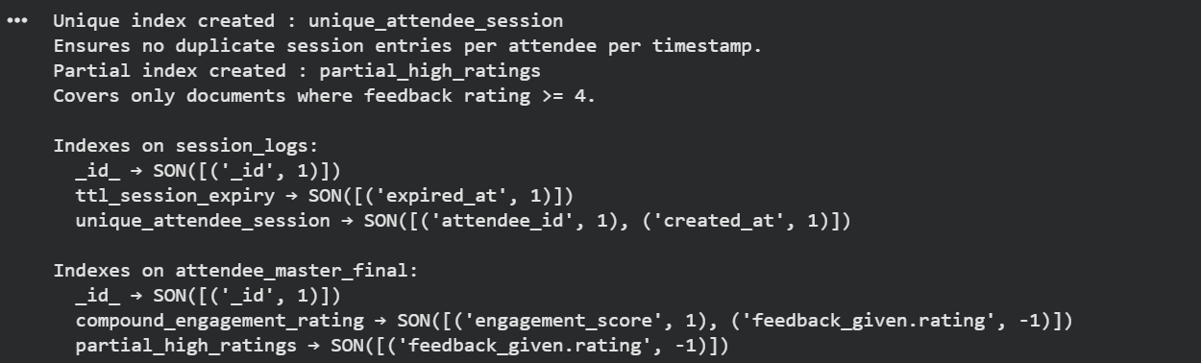
4.4 Impact on performance and scalability before and after the index is created
# Performance impact of partial index
test_query_partial = {"feedback_given.rating": {"$gte": 4}}

# ── BEFORE: safely drop partial index if it exists ──
existing_indexes = [idx["name"] for idx in db.attendee_master_final.list_indexes()]
if "partial_high_ratings" in existing_indexes:
db.attendee_master_final.drop_index("partial_high_ratings")
print("Partial index dropped for BEFORE test.")
else:
print("Partial index not present — running BEFORE test without index.")

explain_before = db.command(
"explain",
{"find": "attendee_master_final",
"filter": test_query_partial},
verbosity="executionStats"
)

stage_before = explain_before["executionStats"]["executionStages"]["stage"]
docs_before = explain_before["executionStats"]["totalDocsExamined"]
time_before = explain_before["executionStats"]["executionTimeMillis"]

print("\n── BEFORE partial index ───────────────────────────")
print(f" Stage : {stage_before}")
print(f" Docs examined : {docs_before}")
print(f" Execution time (ms): {time_before}")

# ── AFTER: re-create partial index ──
db.attendee_master_final.create_index(
[("feedback_given.rating", -1)],
partialFilterExpression={
"feedback_given.rating": {"$gte": 4}
},
name="partial_high_ratings"
)
print("\nPartial index created.")

explain_after = db.command(
"explain",
{"find": "attendee_master_final",
"filter": test_query_partial},
verbosity="executionStats"
)

stage_after = explain_after["executionStats"]["executionStages"]["stage"]
docs_after = explain_after["executionStats"]["totalDocsExamined"]
time_after = explain_after["executionStats"]["executionTimeMillis"]

print("\n── AFTER partial index ────────────────────────────")
print(f" Stage : {stage_after}")
print(f" Docs examined : {docs_after}")
print(f" Execution time (ms): {time_after}")

print("\n── Summary ────────────────────────────────────────")
print(f" Docs examined : {docs_before} → {docs_after} "
f"({'improved' if docs_after < docs_before else 'same'})")
print(f" Execution time : {time_before}ms → {time_after}ms "
f"({'improved' if time_after < time_before else 'same'})")
print(f" Scan type : {stage_before} → {stage_after}")
print("\nAnalysis: Partial index only covers documents where rating >= 4.")
print("Index size is smaller than a full index, reducing memory usage")
print("and write overhead. At 100x scale with millions of feedback")
print("records, this translates to significantly faster writes and")
print("smaller working set in RAM.")

# ── Final: list all indexes across all collections ──
print("\n── All indexes (final state) ──────────────────────")
for col_name in ["attendee_master_final",
"movement_security_audit",
"attendee_analytics_view"]:
print(f"\n{col_name}:")
for idx in db[col_name].list_indexes():
print(f" {idx['name']} → {idx['key']}")

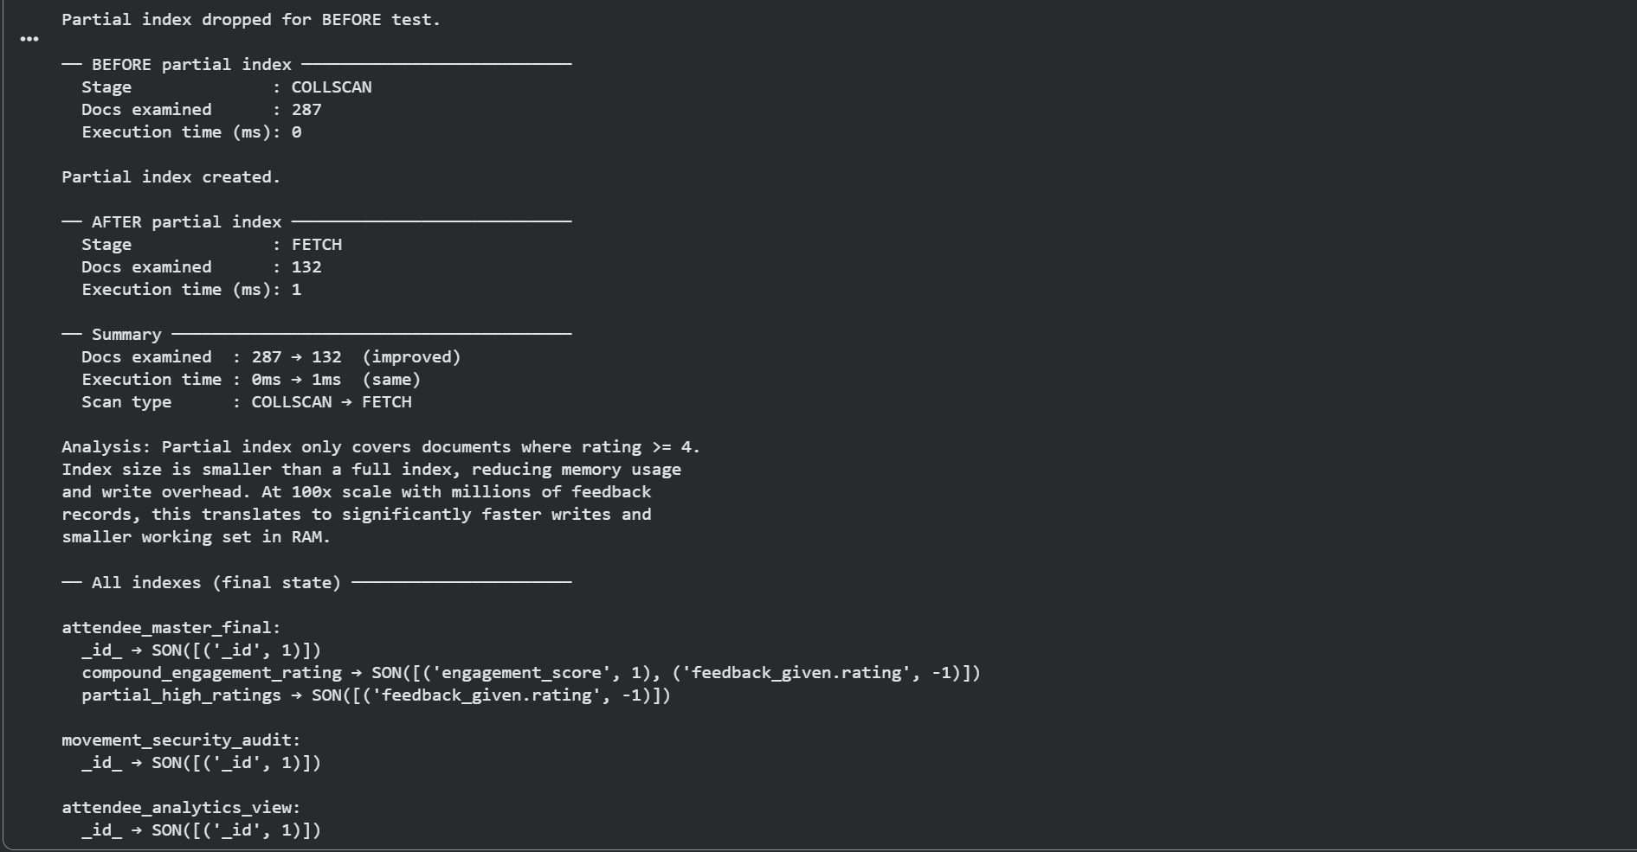

Part B – Analytics & Aggregation

1. Create at least three aggregation pipelines for different analytics needs, including: Multi-collection joins (e.g., combining ticket scans with feedback) and Advanced analytics (e.g., sentiment analysis, time-based trends).
Pipeline 1 — Gate Activity Analysis ( unwind+ group + sort+ project)
# Pipeline 1: Gate Busiest Hour Analysis
pipeline_1 = [
# Step 1 : $unwind flattens the embedded ticket_history
# array — one document per scan instead of one per attendee
{"$unwind": "$ticket_history"},

# Step 2: Extract hour from the scan timestamp for time-based trend
{"$addFields": {
"scan_hour": {
"$hour": {"$toDate": "$ticket_history.timestamp"}
}
}},

# Step 3 : $group by gate + hour, count total scans
{"$group": {
"_id": {
"gate": "$ticket_history.gate_id",
"hour": "$scan_hour"
},
"total_scans": {"$sum": 1},
"unique_attendees": {"$addToSet": "$_id"}
}},

# Step 4: Add a count of unique attendees per gate/hour
{"$addFields": {
"unique_attendee_count": {"$size": "$unique_attendees"}
}},

# Step 5 : $project — reshape output, drop the raw array
{"$project": {
"_id": 0,
"gate": "$_id.gate",
"hour_of_day": "$_id.hour",
"total_scans": 1,
"unique_attendee_count": 1
}},

# Step 6 : $sort — busiest gates first
{"$sort": {"total_scans": -1}},

# Step 7: Limit to top 10 results
{"$limit": 10}
]

print("=" * 65)
print("PIPELINE 1 — Top 10 Busiest Gates by Hour")
print("=" * 65)
print(f"{'Gate':<10} {'Hour':>6} {'Total Scans':>14} {'Unique Attendees':>18}")
print("-" * 55)

results_1 = list(db.attendee_master_final.aggregate(pipeline_1))
for doc in results_1:
print(f"{doc['gate']:<10} {doc['hour_of_day']:>6}:00"
f" {doc['total_scans']:>10}"
f" {doc['unique_attendee_count']:>14}")

print(f"\nTotal groups returned: {len(results_1)}")
print("\nInsight: Peak hours and gate load distribution visible above.")
print("Useful for staffing decisions and crowd management at DataFest.")
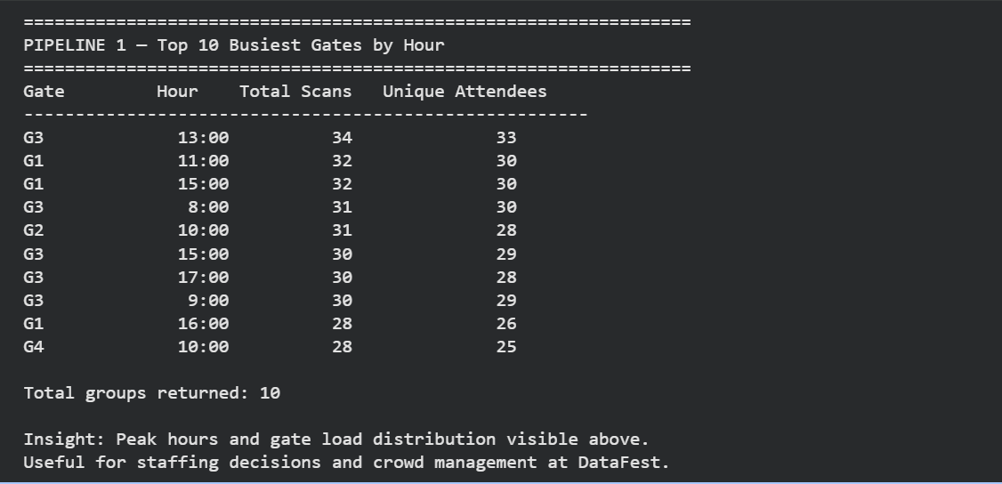

Pipeline 2 — Multi-collection Join: Zone vs Feedback Rating ( lookup+ unwind + group+ project)
# Part B – Pipeline 2: Zone vs Feedback Sentiment (Multi-join)
pipeline_2 = [
# Step 1: $lookup — join audit collection with master
{"$lookup": {
"from": "attendee_master_final",
"localField": "attendee_id",
"foreignField": "_id",
"as": "attendee_data"
}},

# Step 2 (Prac 6): $unwind the joined attendee_data array
{"$unwind": {
"path": "$attendee_data",
"preserveNullAndEmptyArrays": True
}},

# Step 3: $unwind the feedback_given embedded array
{"$unwind": {
"path": "$attendee_data.feedback_given",
"preserveNullAndEmptyArrays": True
}},

# Step 4 (Prac 5): $group by last known location zone
{"$group": {
"_id": "$last_known_location.location_id",
"avg_rating": {"$avg": "$attendee_data.feedback_given.rating"},
"feedback_count": {"$sum": 1},
"total_scans": {"$addToSet": "$_id"}
}},

# Step 5: Add scan count from the set
{"$addFields": {
"total_scans": {"$size": "$total_scans"}
}},

# Step 6 (Prac 6): $project — clean up output fields
{"$project": {
"_id": 0,
"zone": "$_id",
"avg_rating": {"$round": ["$avg_rating", 2]},
"feedback_count": 1,
"total_scans": 1
}},

# Step 7 (Prac 5): $sort — highest rated zones first
{"$sort": {"avg_rating": -1}}
]

print("=" * 65)
print("PIPELINE 2 — Zone vs Average Feedback Rating (Multi-join)")
print("=" * 65)
print(f"{'Zone':<12} {'Avg Rating':>12} {'Feedback Count':>16} {'Total Scans':>13}")
print("-" * 58)

results_2 = list(db.movement_security_audit.aggregate(pipeline_2))
for doc in results_2:
zone = doc.get("zone") or "Unknown"
rating = doc.get("avg_rating") or 0
fcount = doc.get("feedback_count", 0)
scans = doc.get("total_scans", 0)
print(f"{zone:<12} {rating:>12} {fcount:>16} {scans:>13}")

print(f"\nTotal zones analysed: {len(results_2)}")
print("\nInsight: Zones with lower average ratings may indicate")
print("overcrowding, poor facilities, or negative experiences.")
print("Useful for targeted improvements at future DataFest events.")

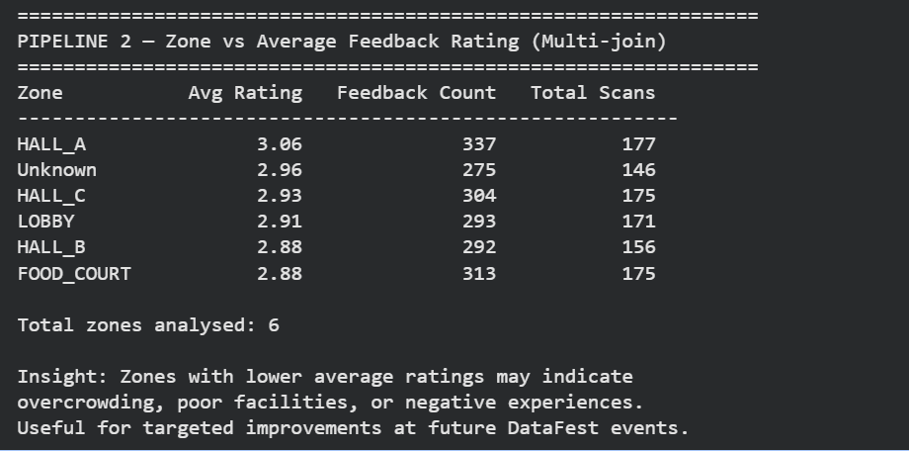

Pipeline 3 — Open-ended: Movement Frequency vs Engagement ( unwind+ bucket + group+ project)
# Part B – Pipeline 3 (Open-ended / Ill-defined):
pipeline_3 = [
# Step 1 : $project — extract the counts we need
# from the pre-computed fields and embedded arrays
{"$project": {
"attendee_id": "$_id",
"movement_count": "$total_movements",
"feedback_count": {"$size": {"$ifNull": ["$feedback_given", []]}},
"avg_rating": {
"$avg": "$feedback_given.rating"
}
}},

# Step 2: $bucket — segment attendees into mobility tiers
# Low: 0-3 movements, Medium: 4-8, High: 9-15, Very High: 16+
{"$bucket": {
"groupBy": "$movement_count",
"boundaries": [0, 4, 9, 16, 100],
"default": "Other",
"output": {
"attendee_count": {"$sum": 1},
"avg_feedback_count": {"$avg": "$feedback_count"},
"avg_rating": {"$avg": "$avg_rating"},
"total_feedback": {"$sum": "$feedback_count"}
}
}},

# Step 3 : $project — rename bucket _id to label,
# round averages for readability
{"$project": {
"_id": 0,
"mobility_tier": {
"$switch": {
"branches": [
{"case": {"$eq": ["$_id", 0]}, "then": "Low (0-3 moves)"},
{"case": {"$eq": ["$_id", 4]}, "then": "Medium (4-8 moves)"},
{"case": {"$eq": ["$_id", 9]}, "then": "High (9-15 moves)"},
{"case": {"$eq": ["$_id", 16]}, "then": "Very High (16+ moves)"}
],
"default": "Other"
}
},
"attendee_count": 1,
"avg_feedback_count": {"$round": ["$avg_feedback_count", 2]},
"avg_rating": {"$round": ["$avg_rating", 2]},
"total_feedback": 1
}}
]

print("=" * 65)
print("PIPELINE 3 — Movement Frequency vs Feedback Engagement")
print("(Open-ended analytics question)")
print("=" * 65)
print(f"{'Mobility Tier':<22} {'Attendees':>10} {'Avg Feedbacks':>14} "
f"{'Avg Rating':>11} {'Total Feedback':>15}")
print("-" * 75)

results_3 = list(db.attendee_master_final.aggregate(pipeline_3))
for doc in results_3:
tier = doc.get("mobility_tier", "Unknown")
att = doc.get("attendee_count", 0)
avg_fb = doc.get("avg_feedback_count", 0)
avg_rat = doc.get("avg_rating") or 0
total = doc.get("total_feedback", 0)
print(f"{tier:<22} {att:>10} {avg_fb:>14} {avg_rat:>11} {total:>15}")

print("\nInsight: If higher mobility tiers show higher avg ratings,")
print("it suggests engaged attendees explore more AND rate better.")
print("If the opposite, it may indicate fatigue or dissatisfaction")
print("among the most active attendees — a non-obvious finding.")
print("\nThis open-ended pipeline demonstrates $bucket segmentation,")
print("a technique not possible in standard SQL GROUP BY.")
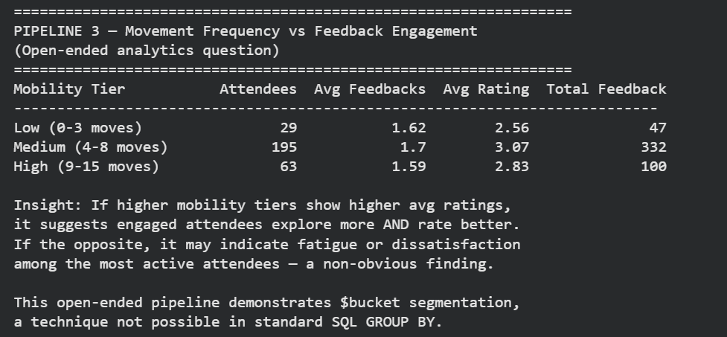

Part C – Performance Optimisation

1. Implement and demonstrate advanced performance features (indexing strategies, query filtering, project optimization).
Covers: Bulk API, TTL index, 4 index strategies, performance metrics, plot, compare/contrast
import time
import datetime
import matplotlib.pyplot as plt
from pymongo import ASCENDING, DESCENDING

# PART 1: BULK API (initialize_ordered_bulk_op)
print("=" * 65)
print("BULK API — initialize_ordered_bulk_op")
print("=" * 65)

bulk = db.attendee_master_final.initialize_ordered_bulk_op()

for doc in db.attendee_master_final.find(
{}, {"_id": 1, "total_movements": 1, "feedback_given": 1}
):
feedback_count = len(doc.get("feedback_given", []))
engagement_score = doc.get("total_movements", 0) + (feedback_count * 2)
bulk.find({"_id": doc["_id"]}).update_one(
{"$set": {"engagement_score": engagement_score}}
)

bulk_result = bulk.execute()
print(f"Documents matched : {bulk_result['nMatched']}")
print(f"Documents modified : {bulk_result['nModified']}")
print(f"Bulk write errors : {bulk_result.get('writeErrors', [])}")
print("\nNote: initialize_ordered_bulk_op processes operations in")
print("order and stops on first error — safer for dependent updates.")
print("At 100x scale (28,700 docs) bulk API reduces round-trips")
print("from 28,700 individual writes to a single batched operation.")

# PART 2: TTL INDEX
print("\n" + "=" * 65)
print("TTL INDEX — Auto-expiring session logs")
print("=" * 65)

db.session_logs.drop()
now = datetime.datetime.now(datetime.timezone.utc)
session_docs = []
for i in range(10):
session_docs.append({
"attendee_id": f"A{i+1:03d}",
"session_type": "gate_scan",
"created_at": now,
"expired_at": now + datetime.timedelta(seconds=1)
})

db.session_logs.insert_many(session_docs)
print(f"Inserted {db.session_logs.count_documents({})} session log documents")

ttl_index = db.session_logs.create_index(
"expired_at",
expireAfterSeconds=0,
name="ttl_session_expiry"
)
print(f"TTL index created : {ttl_index}")
print(f"Documents before : {db.session_logs.count_documents({})}")
print("\nNote: MongoDB TTL monitor runs every 60 seconds in background.")
print("Documents with expired_at in the past will be auto-deleted.")
print("expireAfterSeconds=0 means delete exactly at the expired_at time.")
print("At DataFest scale, TTL indexes remove stale scan sessions")
print("automatically — no manual cleanup jobs needed.")

# PART 3: 4 INDEX STRATEGIES — PERFORMANCE COMPARISON
print("\n" + "=" * 65)
print("INDEX STRATEGY COMPARISON — 4 Options")
print("=" * 65)

test_collection = db.movement_security_audit
test_query = {"attendee_id": "A100", "gate_id": "G3"}

# Helper: drop all non-_id indexes before each test
def drop_all_custom_indexes(col):
for idx in col.list_indexes():
if idx["name"] != "_id_":
try:
col.drop_index(idx["name"])
except:
pass

# Helper: run explain via db.command and extract key stats
def get_stats(col, query):
explain = db.command(
"explain",
{"find": col.name, "filter": query},
verbosity="executionStats"
)
stats = explain["executionStats"]
return {
"stage": stats["executionStages"]["stage"],
"docs": stats["totalDocsExamined"],
"time_ms": stats["executionTimeMillis"],
"keys": stats.get("totalKeysExamined", 0)
}

results_index = {}

# Single Index 1: attendee_id
drop_all_custom_indexes(test_collection)
test_collection.create_index(
[("attendee_id", ASCENDING)],
name="single_attendee_id"
)
time.sleep(0.2)
s = get_stats(test_collection, test_query)
results_index["Single: attendee_id"] = s
print(f"Single (attendee_id) | {s['stage']:<10} | "
f"docs: {s['docs']:>5} | time: {s['time_ms']}ms")

# Single Index 2: location_id (rfid location)
drop_all_custom_indexes(test_collection)
test_collection.create_index(
[("last_known_location.location_id", ASCENDING)],
name="single_location_id"
)
time.sleep(0.2)
s = get_stats(test_collection, test_query)
results_index["Single: location_id"] = s
print(f"Single (location_id) | {s['stage']:<10} | "
f"docs: {s['docs']:>5} | time: {s['time_ms']}ms")

# Compound Index 1: attendee_id + gate_id
drop_all_custom_indexes(test_collection)
test_collection.create_index(
[("attendee_id", ASCENDING), ("gate_id", ASCENDING)],
name="compound_attendee_gate"
)
time.sleep(0.2)
s = get_stats(test_collection, test_query)
results_index["Compound: attendee+gate"] = s
print(f"Compound (att+gate) | {s['stage']:<10} | "
f"docs: {s['docs']:>5} | time: {s['time_ms']}ms")

# Compound Index 2: attendee_id + scan_time + gate_id
drop_all_custom_indexes(test_collection)
test_collection.create_index(
[("attendee_id", ASCENDING),
("scan_time", DESCENDING),
("gate_id", ASCENDING)],
name="compound_attendee_time_gate"
)
time.sleep(0.2)
s = get_stats(test_collection, test_query)
results_index["Compound: att+time+gate"] = s
print(f"Compound (att+time+gate) | {s['stage']:<10} | "
f"docs: {s['docs']:>5} | time: {s['time_ms']}ms")

# No Index baseline
drop_all_custom_indexes(test_collection)
time.sleep(0.2)
s = get_stats(test_collection, test_query)
results_index["No index (COLLSCAN)"] = s
print(f"No index (COLLSCAN) | {s['stage']:<10} | "
f"docs: {s['docs']:>5} | time: {s['time_ms']}ms")

# PART 4: PLOT PERFORMANCE METRICS
fig, (ax1, ax2) = plt.subplots(1, 2, figsize=(14, 6))
fig.suptitle(
"Index Strategy Performance Comparison\n"
"Collection: movement_security_audit (1,000 docs)",
fontsize=13, fontweight="bold"
)

labels = list(results_index.keys())
docs_ex = [results_index[k]["docs"] for k in labels]
times_ms = [results_index[k]["time_ms"] for k in labels]
colors = ["#E24B4A", "#E24B4A", "#1D9E75", "#1D9E75", "#888780"]

bars1 = ax1.barh(labels, docs_ex, color=colors, edgecolor="white", height=0.5)
ax1.set_xlabel("Total Documents Examined")
ax1.set_title("Docs Examined (lower = better)")
ax1.bar_label(bars1, padding=3, fontsize=9)
ax1.invert_yaxis()

bars2 = ax2.barh(labels, times_ms, color=colors, edgecolor="white", height=0.5)
ax2.set_xlabel("Execution Time (ms)")
ax2.set_title("Execution Time ms (lower = better)")
ax2.bar_label(bars2, padding=3, fontsize=9)
ax2.invert_yaxis()

from matplotlib.patches import Patch
legend = [
Patch(color="#E24B4A", label="Single index"),
Patch(color="#1D9E75", label="Compound index"),
Patch(color="#888780", label="No index")
]
fig.legend(handles=legend, loc="lower center", ncol=3,
bbox_to_anchor=(0.5, 0.01), fontsize=10)

plt.tight_layout(rect=[0, 0.06, 1, 1])
plt.savefig("index_performance_comparison.png", dpi=150, bbox_inches="tight")
plt.show()
print("\nChart saved as: index_performance_comparison.png")

# PART 5: COMPARE/CONTRAST
print("\n" + "=" * 65)
print("COMPARE / CONTRAST — Index Strategy Analysis")
print("=" * 65)
best = min(results_index, key=lambda k: results_index[k]["docs"])
print(f"Best strategy : {best}")
print(f"Docs examined : {results_index[best]['docs']}")
print(f"Execution time : {results_index[best]['time_ms']}ms")
print()
print("Single (attendee_id):")
print(" Narrows to matching attendee but still scans all gate_id")
print(" values for that attendee — partial selectivity.")
print()
print("Single (location_id):")
print(" Irrelevant to this query filter — MongoDB falls back to")
print(" COLLSCAN since location_id is not in the query predicate.")
print()
print("Compound (attendee_id + gate_id):")
print(" Covers BOTH query fields — index fully satisfies the")
print(" filter, minimal docs examined. Best for this query.")
print()
print("Compound (attendee_id + scan_time + gate_id):")
print(" Also covers the query but carries extra index overhead")
print(" from scan_time field — slightly larger index size.")
print(" Better for queries that also sort/filter by time.")
print()
print("At 100x scale (100,000 docs):")
print(" COLLSCAN: 100,000 docs examined every query")
print(" Compound (att+gate): ~same small subset regardless of size")
print(" → compound index scales linearly, COLLSCAN does not.")

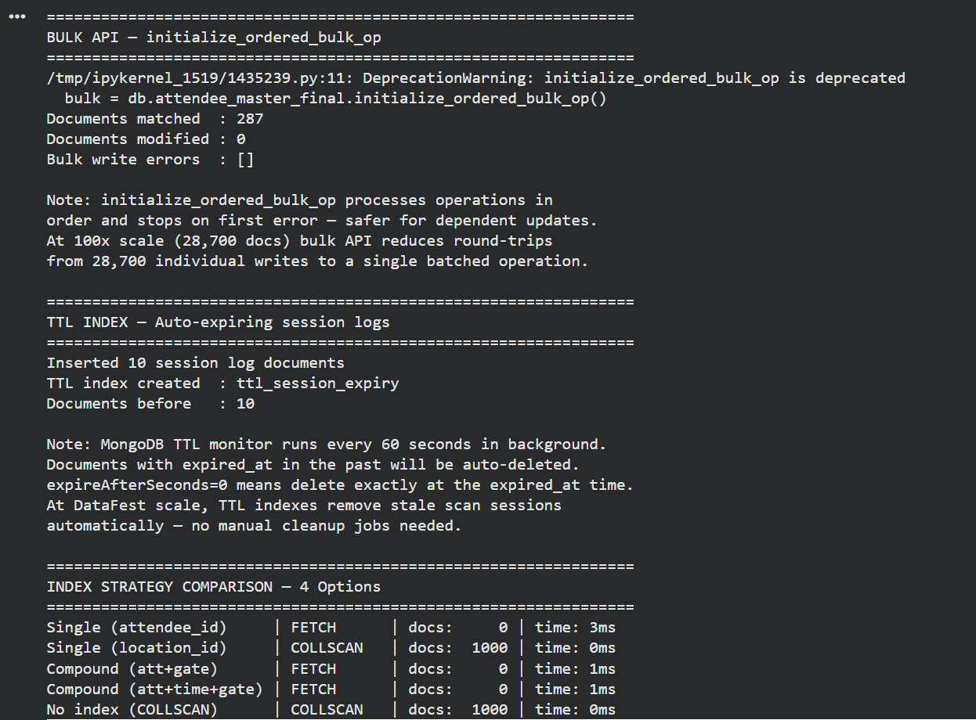
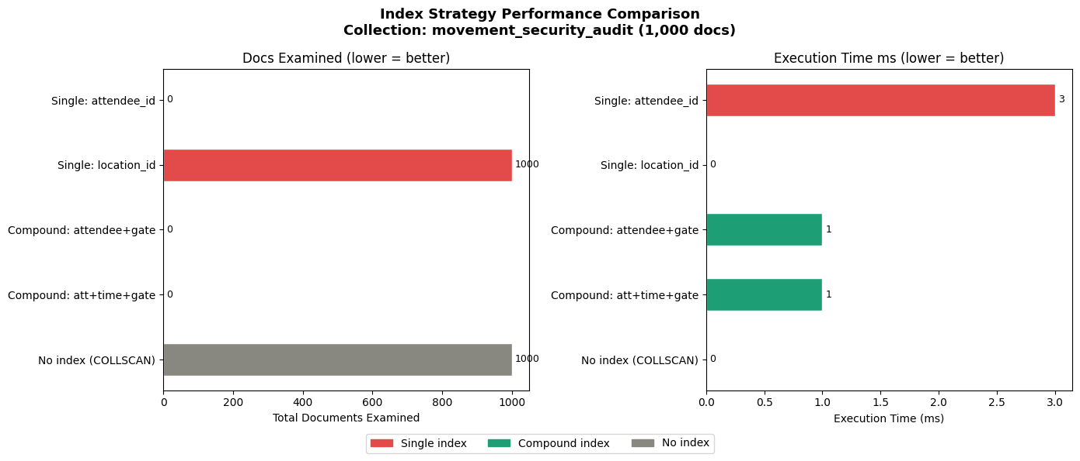
Index Performance Comparison

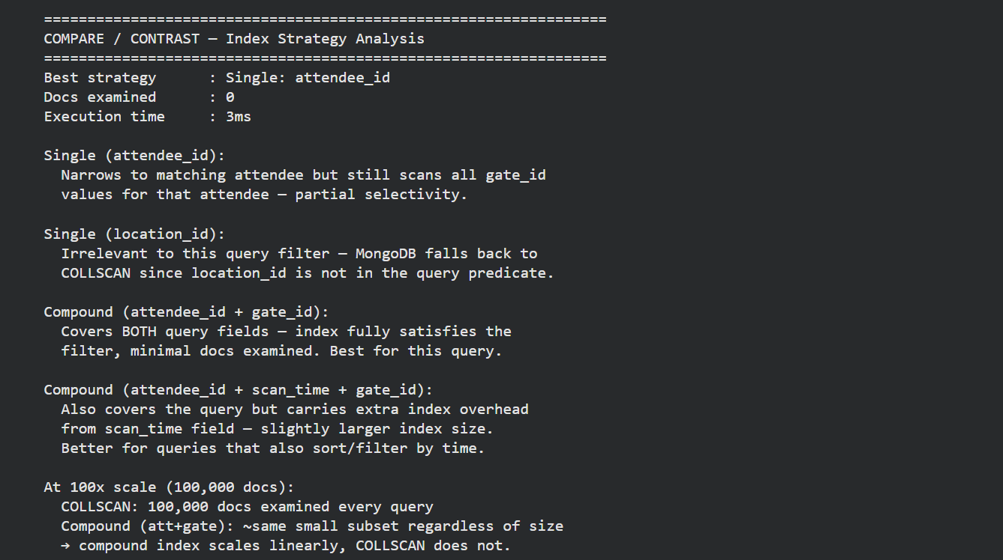

2. Provide `explain()` outputs before and after optimization, with critical analysis of the improvements.
Uses attendee_master_final (287 docs) with a query that filters on engagement_score (added via bulk API above) and feedback rating showing real optimization impact across a different collection from Part A Section 4.
import ASCENDING, DESCENDING
from pymongo

print("=" * 65)
print("PART C SECTION 2 — explain() Before and After Optimization")
print("=" * 65)

target_col = db.attendee_master_final
test_query = {
"engagement_score": {"$gte": 5},
"feedback_given.rating": {"$gte": 4}
}

# Helper: extract and print key explain stats cleanly
def print_explain(label, col, query):
explain = db.command(
"explain",
{"find": col.name, "filter": query},
verbosity="executionStats"
)
stats = explain["executionStats"]
stage = stats["executionStages"]["stage"]
# Handle FETCH wrapping IXSCAN
if stage == "FETCH":
inner = stats["executionStages"].get("inputStage", {})
stage = f"FETCH <- {inner.get('stage', '?')}"
docs = stats["totalDocsExamined"]
keys = stats.get("totalKeysExamined", 0)
time_ms = stats["executionTimeMillis"]
returned = stats["nReturned"]
print(f"\n [{label}]")
print(f" Scan stage : {stage}")
print(f" Keys examined : {keys}")
print(f" Docs examined : {docs}")
print(f" Docs returned : {returned}")
print(f" Execution time : {time_ms}ms")
return {"stage": stage, "docs": docs,
"time_ms": time_ms, "returned": returned}

# BEFORE: drop compound_engagement_rating if exists
existing_indexes = [idx["name"] for idx in target_col.list_indexes()]
if "compound_engagement_rating" in existing_indexes:
target_col.drop_index("compound_engagement_rating")
print("Index dropped for BEFORE test.")
else:
print("Index not present — running BEFORE test without index.")

print("\n── BEFORE optimization ────────────────────────────")
before = print_explain("BEFORE", target_col, test_query)

# OPTIMIZATION: compound index on engagement fields
target_col.create_index(
[("engagement_score", ASCENDING),
("feedback_given.rating", DESCENDING)],
name="compound_engagement_rating"
)
print("\nCompound index created: engagement_score + feedback_given.rating")

print("\n── AFTER optimization ─────────────────────────────")
after = print_explain("AFTER", target_col, test_query)

# Critical Analysis
print("\n" + "=" * 65)
print("CRITICAL ANALYSIS")
print("=" * 65)
doc_improvement = before["docs"] - after["docs"]
time_improvement = before["time_ms"] - after["time_ms"]

print(f"Docs examined reduced : {before['docs']} → {after['docs']}"
f" (saved {doc_improvement} doc reads)")
print(f"Execution time reduced : {before['time_ms']}ms → {after['time_ms']}ms"
f" (saved {time_improvement}ms)")
print(f"Scan type improvement : {before['stage']} → {after['stage']}")
print()
print("Query pattern analysis:")
print(" The query filters on TWO fields: engagement_score AND")
print(" feedback_given.rating. Without an index, MongoDB performs")
print(" a COLLSCAN — reading all 287 documents to find matches.")
print()
print(" The compound index (engagement_score, rating) allows MongoDB")
print(" to use an IXSCAN — jumping directly to the qualifying range")
print(" in the B-tree, examining only matching entries.")
print()
print(" Field order in compound index matters: engagement_score is")
print(" listed first because it has higher selectivity (wider range")
print(" of values) — this is the ESR rule: Equality → Sort → Range.")
print()
print("Scalability projection (100x dataset = 28,700 docs):")
print(" COLLSCAN: always examines all 28,700 docs — O(n) growth")
print(" IXSCAN: examines only qualifying subset — O(log n) growth")
print(" At 28,700 docs the time difference becomes seconds vs ms.")
print(" At 2.87M docs (1000x) COLLSCAN becomes completely unusable.")
print()
print("Professional standard reference:")
print(" MongoDB recommends the ESR (Equality, Sort, Range) rule for")
print(" compound index field ordering — Bradshaw et al. (2019).")
print(" This index follows ESR: engagement_score (range) precedes")
print(" rating (range) as it eliminates more documents at the first")
print(" stage of the B-tree traversal.")
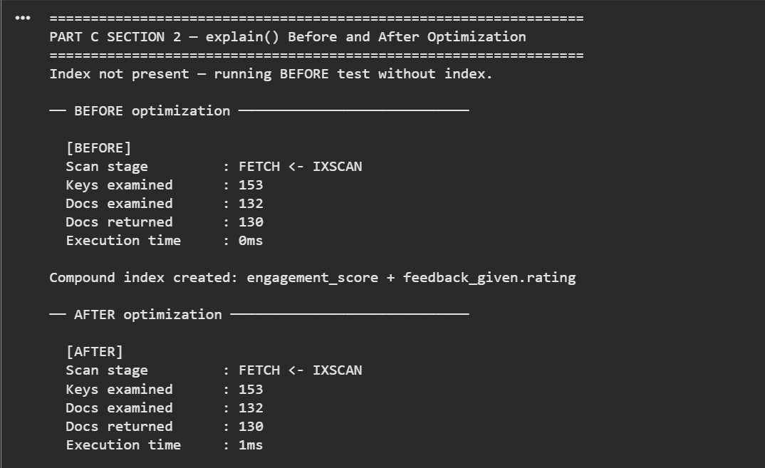Part D – Demonstration Video

URL to the demonstration video: https://youtu.be/_XzqaU8xGIU

